SITK® for LabView™ 64 bit Software
Quick Start for Cameras

Version 5.0.x.x

- Open ExOpenGlobalCam.vi in the “Fast Examples\Open-Close Hardware” folder. Run the VI and the Camera Open. LED should turn green and no errors should occur.
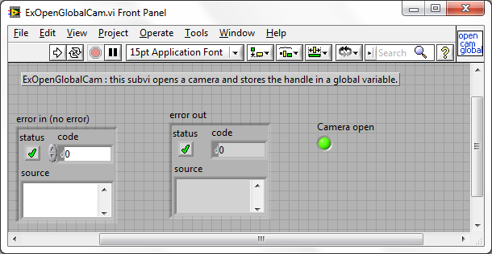

- Next run ExSetupROI.vi from either the “Cameras”, “Pixis”, or “Pulser Systems” folder under “Fast Examples”. Put a legal value into the x2 (x end or size) and y2 (y end or y size). Run the vi. There should be a valid ADC Speed to the right. If ADC Speed of -2 was used, it should show the fastest speed. If -3 was used, it should show the slowest speed.
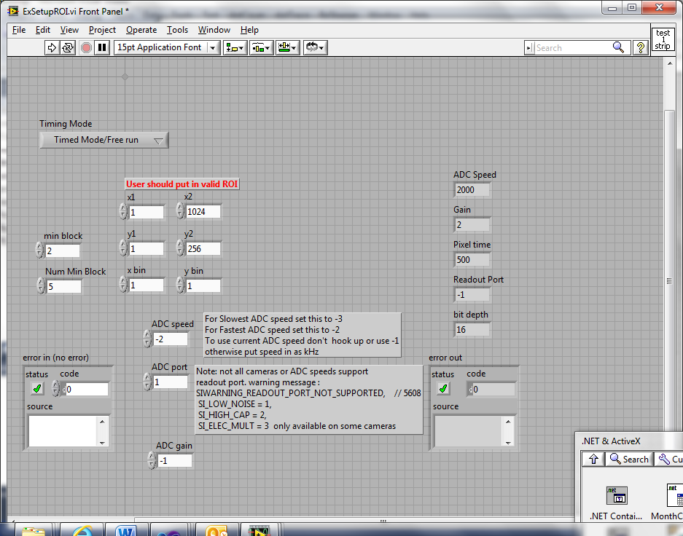

- Next run the ExDataCollectFocusImageROT.vi. When the LED turns green, hit the start button and data should be displayed in the image window.
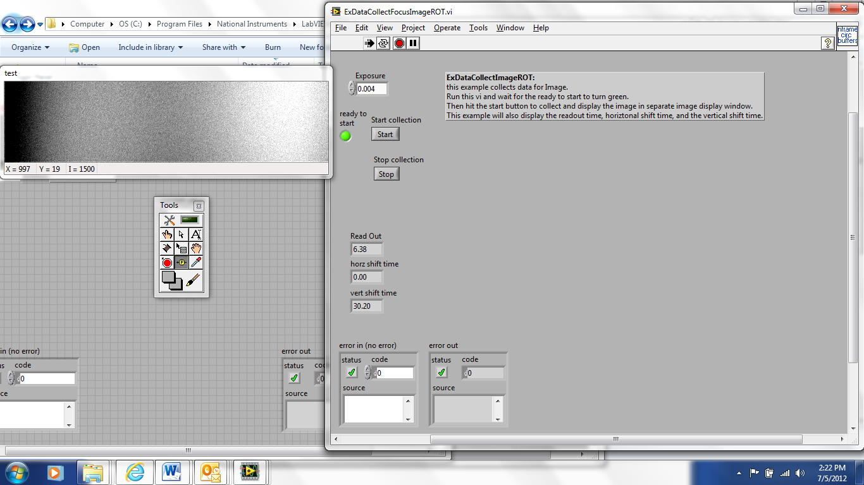

- If there are problems you can verify the camera drivers and version numbers by running the DiagnosticCameratestglbhdl.vi.
